LAMBTON COLLEGE



**A Report on**

[**Lab 1,2,3 on AWS Cloud Foundations]**

121 Brunel Rd, Mississauga

ON L4Z 3E9

A Group assignment with screenshots of Lab 1, 2, and 3

on Aws academy

Big Data Analytics DSMM

**Under the supervision**

**of**

**Professor Pedram Habibi**

**Submitted BY:**

Aadarsha Chapagain (C0825975)

Davinderjit Singh (C0833117)

Priti Bhale (C0835691)

Milanjeet Kaur(C0829899)

Palwinder Kaur (C0827804)

Nimmo Usman (C0836309)

**Submitted To:**

Lambton College

Professor Pedram Habibi

**Submission Date:**

11th  November 2022

**Lab1**

**Start lab**

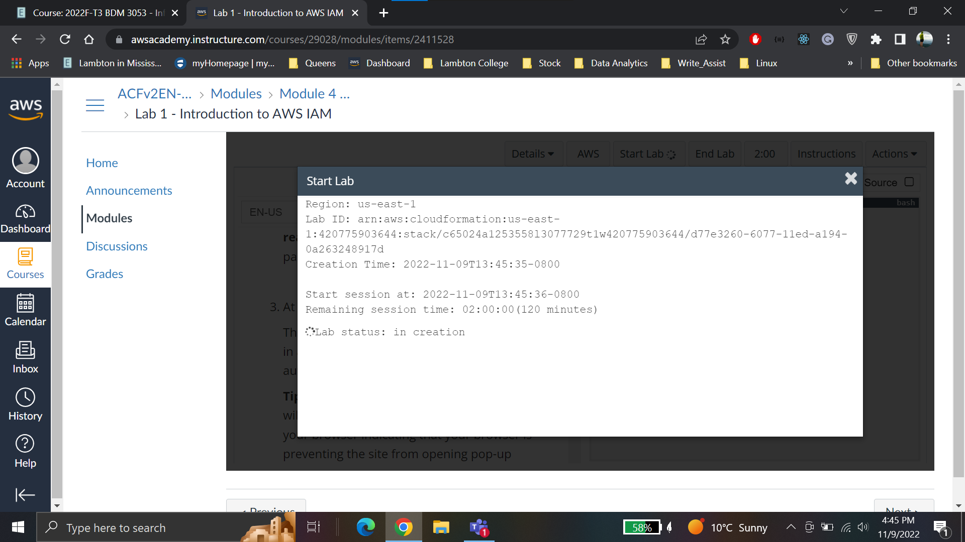

**User list**

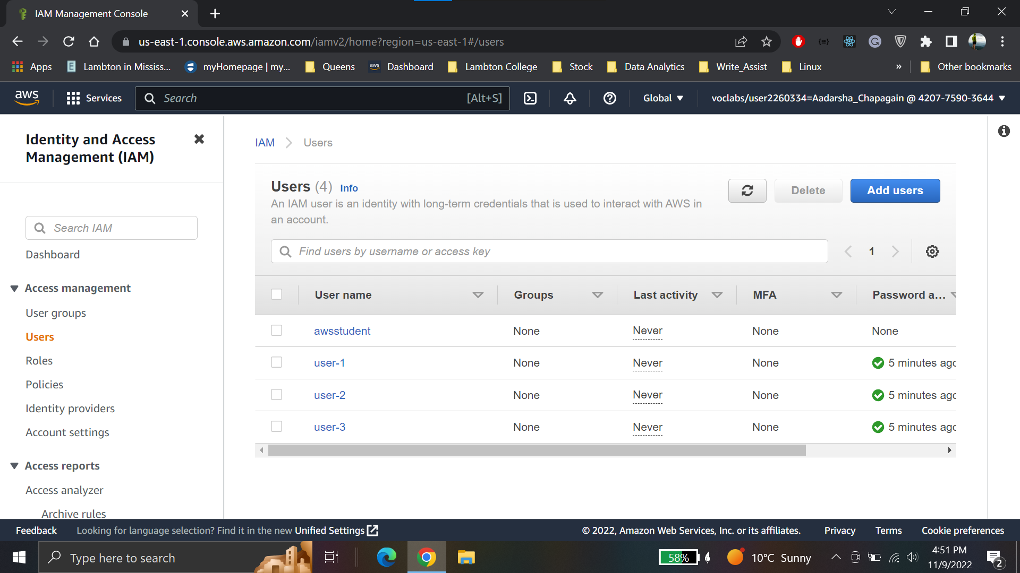

**User groups**

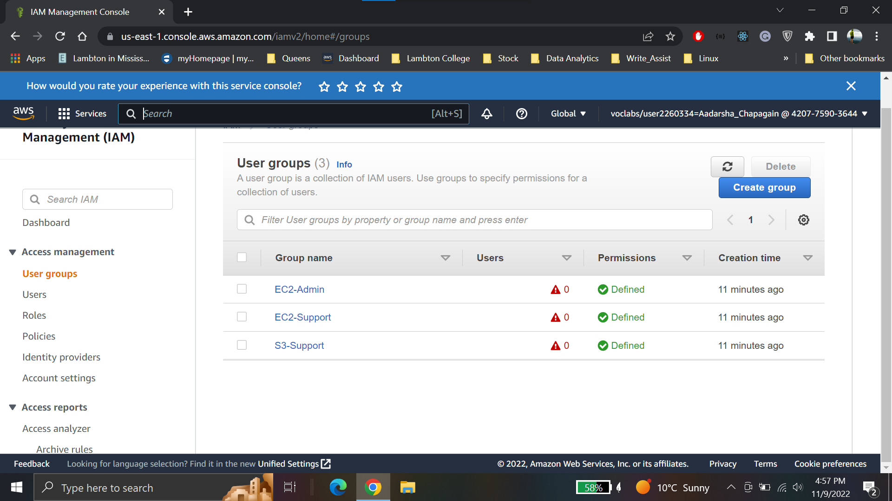

**Effect, Action, resource**

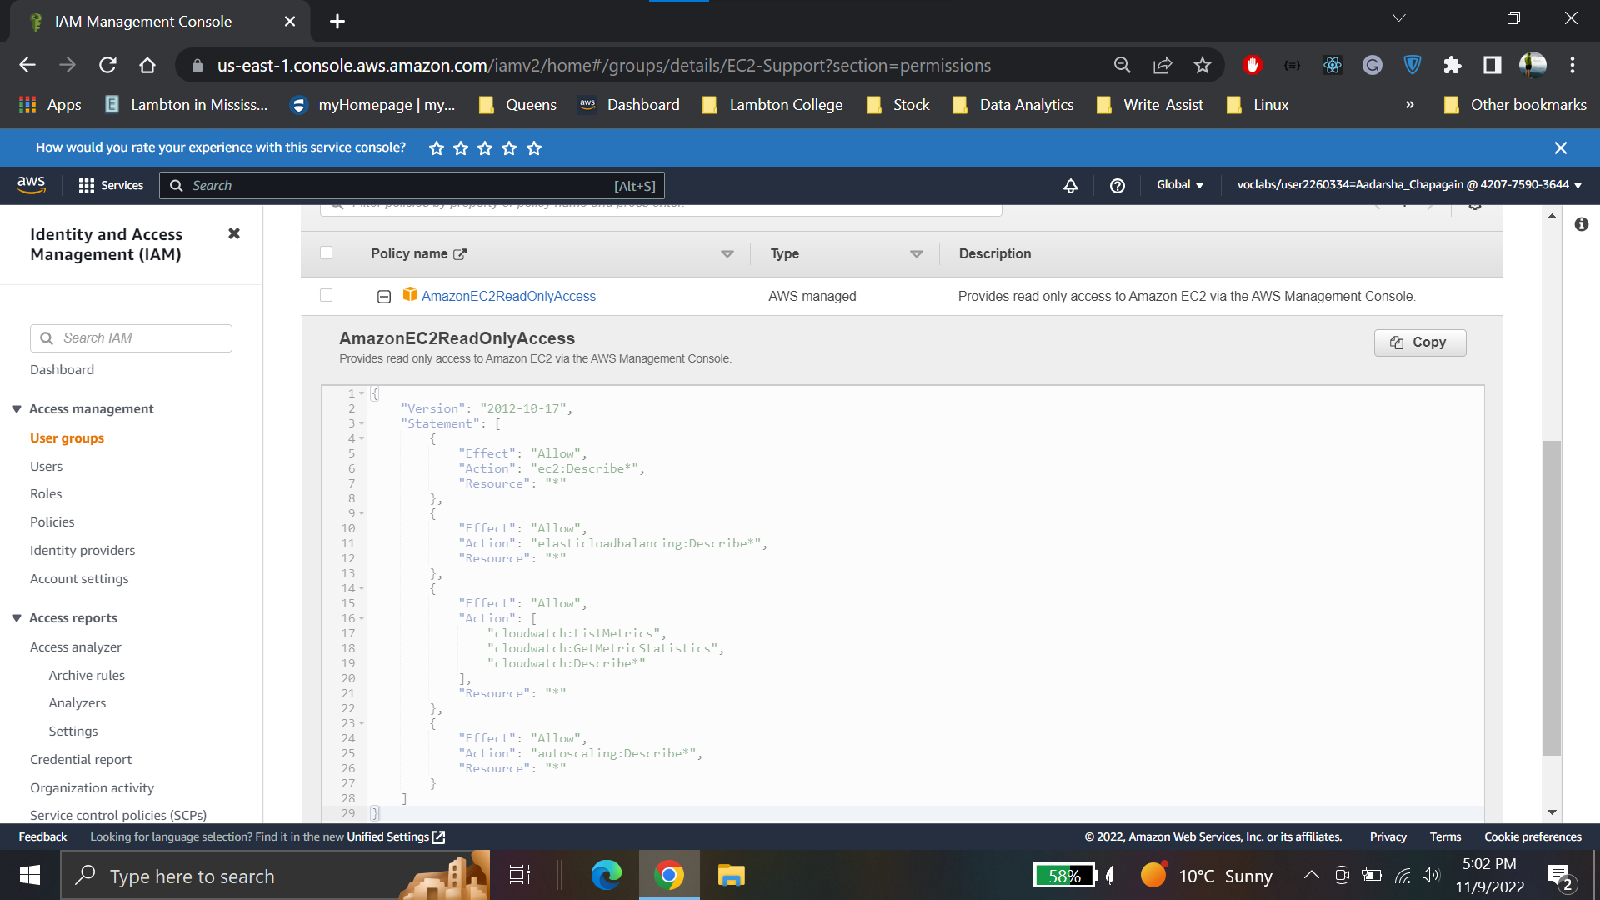

**Inline policy**

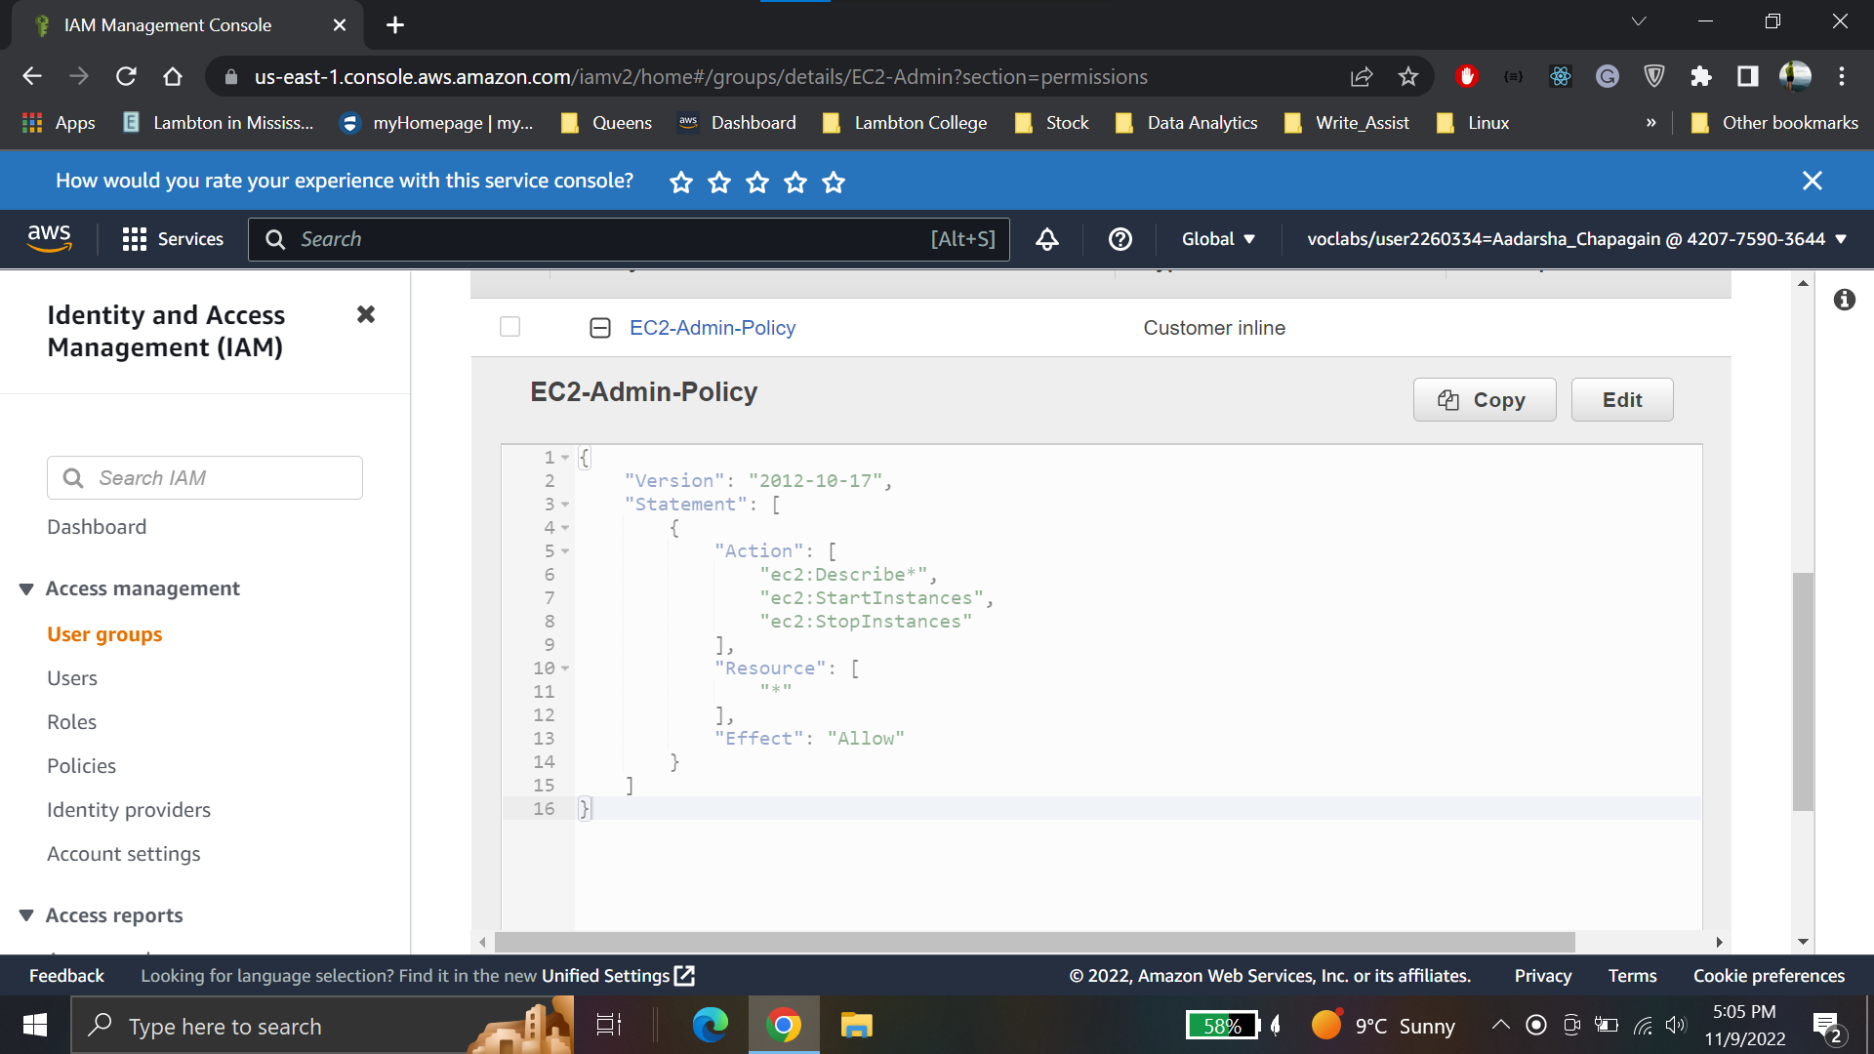

**Business Scenario**

**Add user-1 to S3**

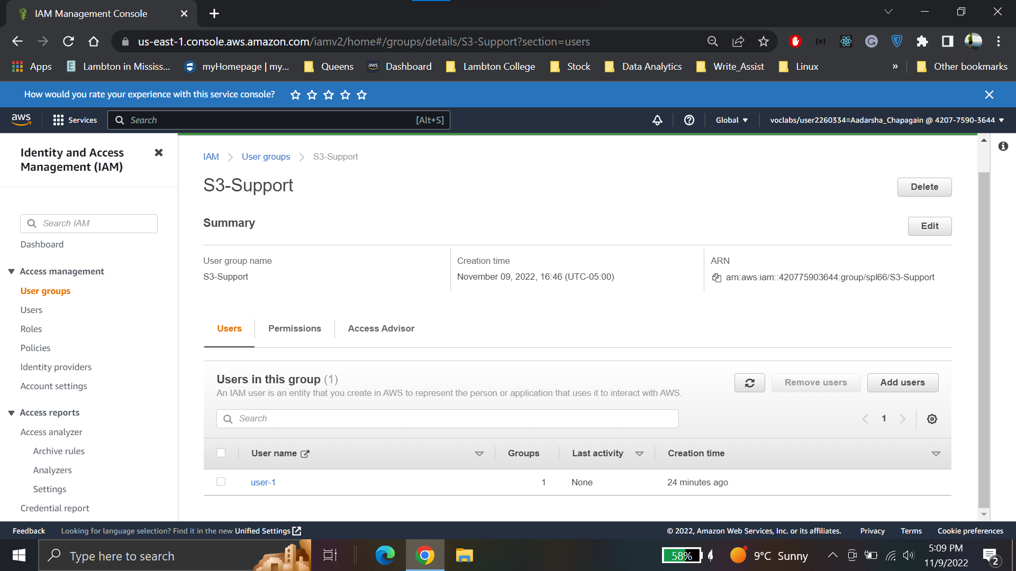

**Add user-2 to the EC2-Support Group**

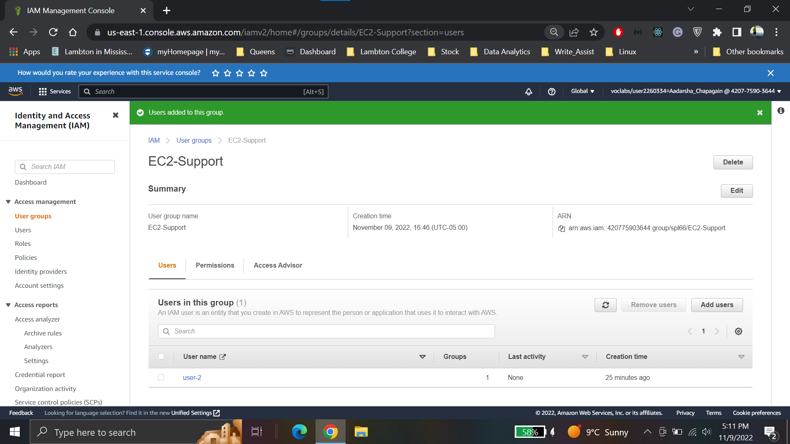

**Add user-3 to the EC2-Admin Group**

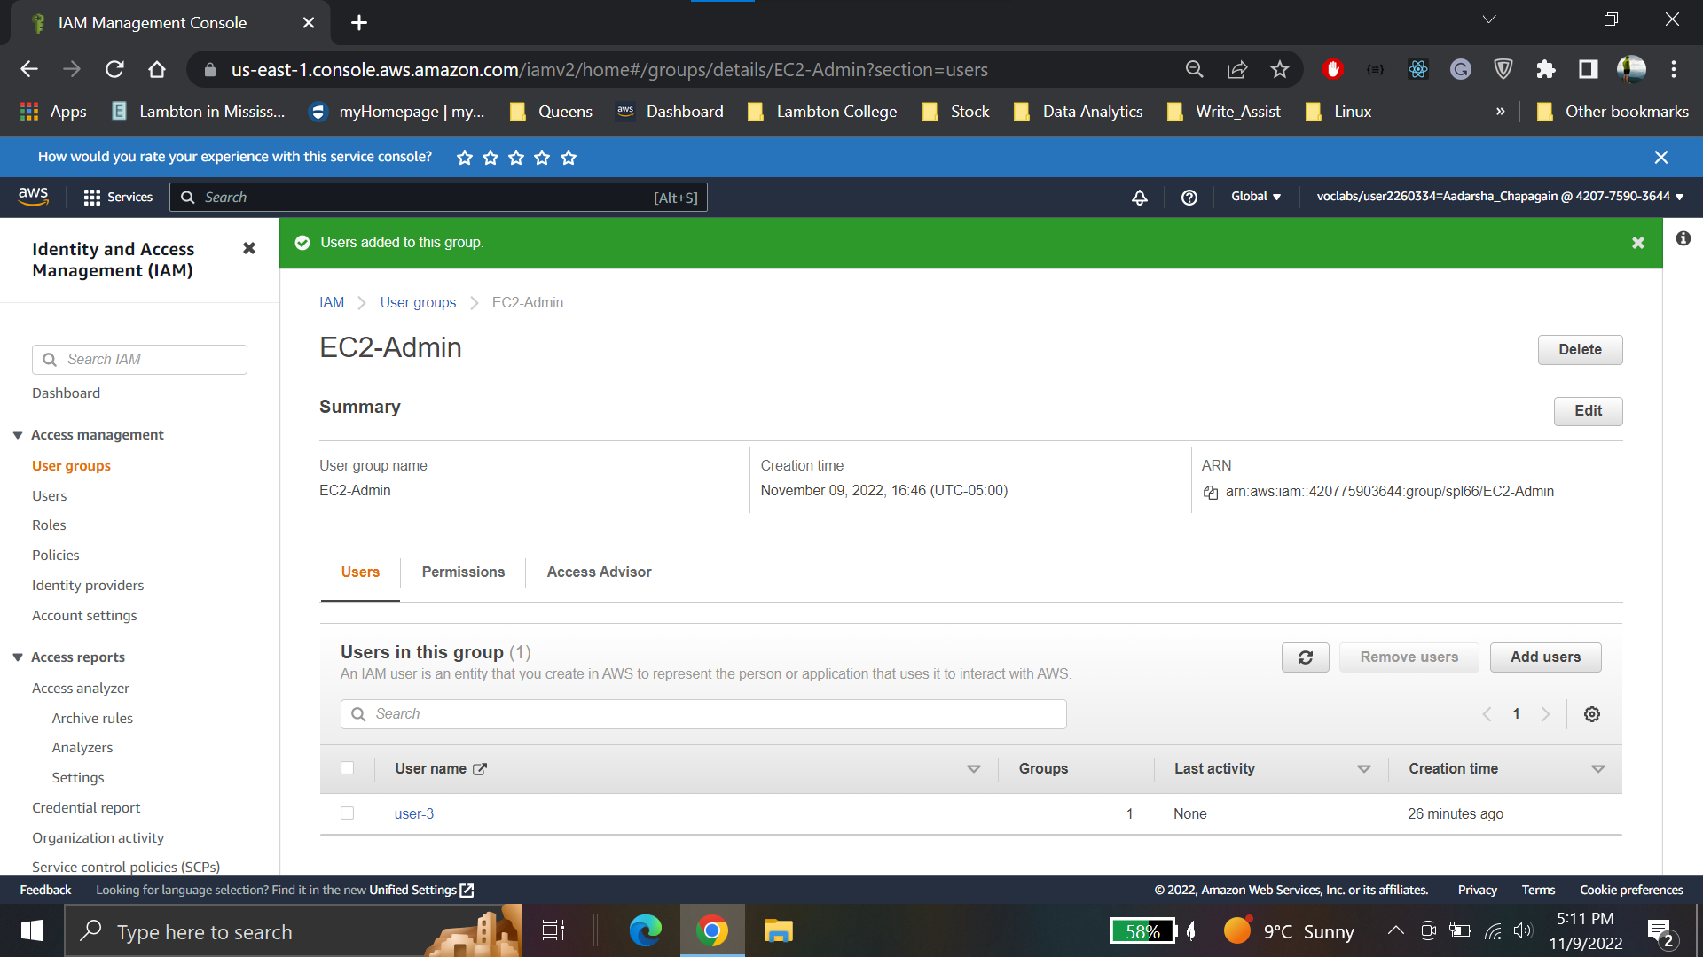

**User-1 has acces to S3 bucket**

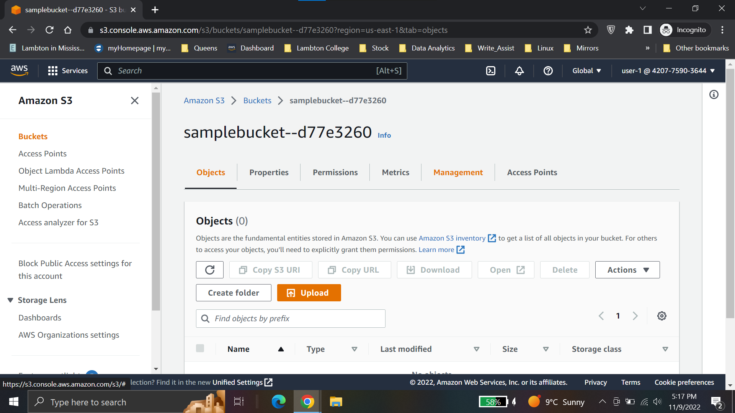

**User-1 has no access to EC2 instance**

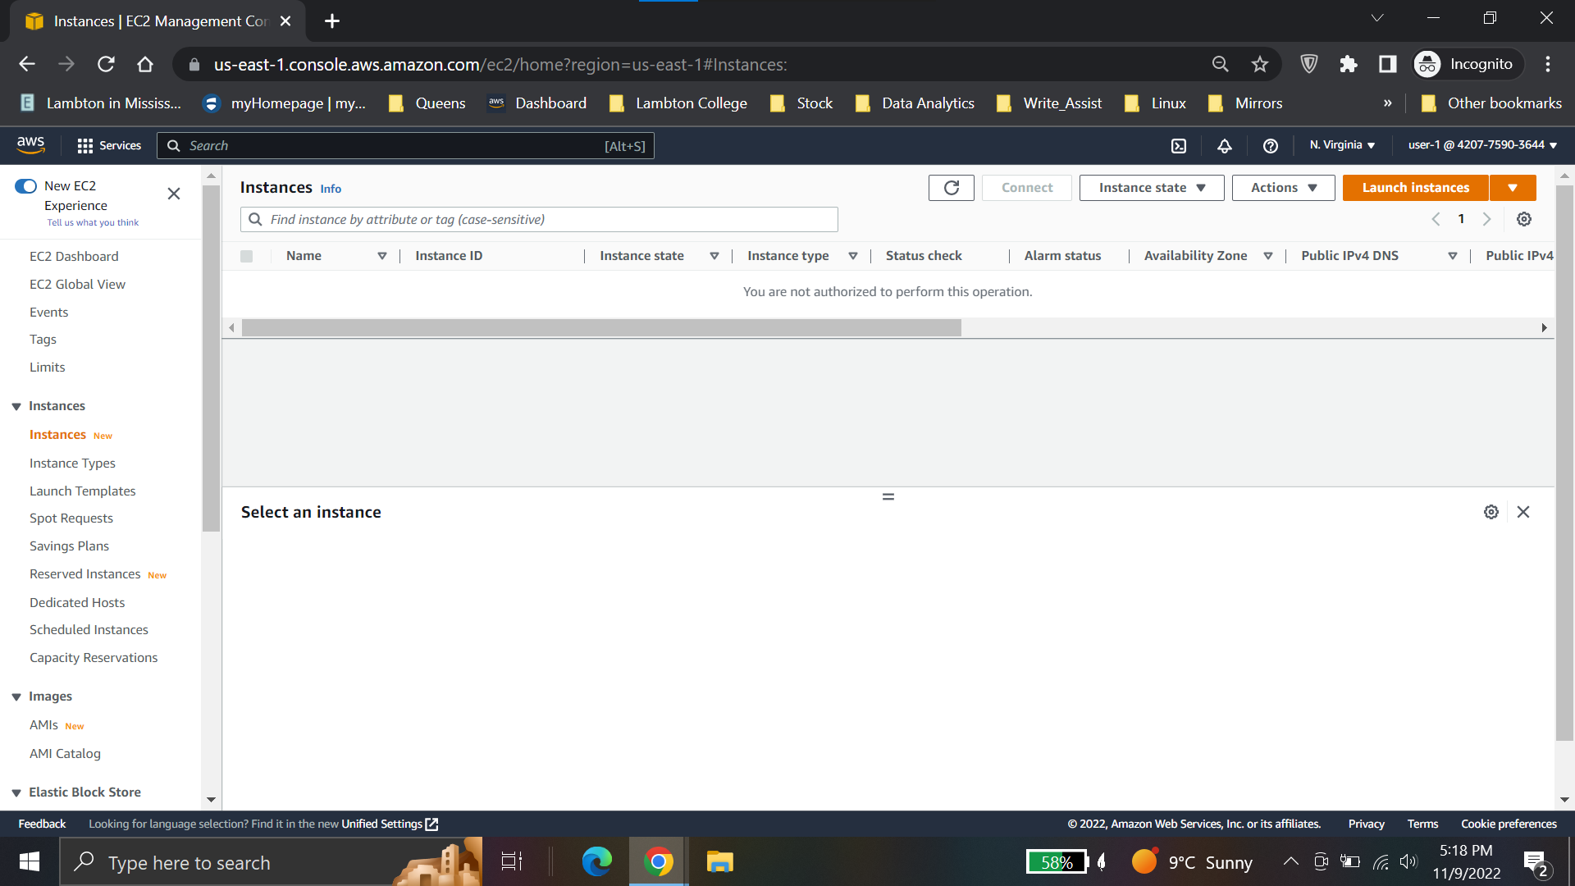

**User-2 has access to EC2 instances**

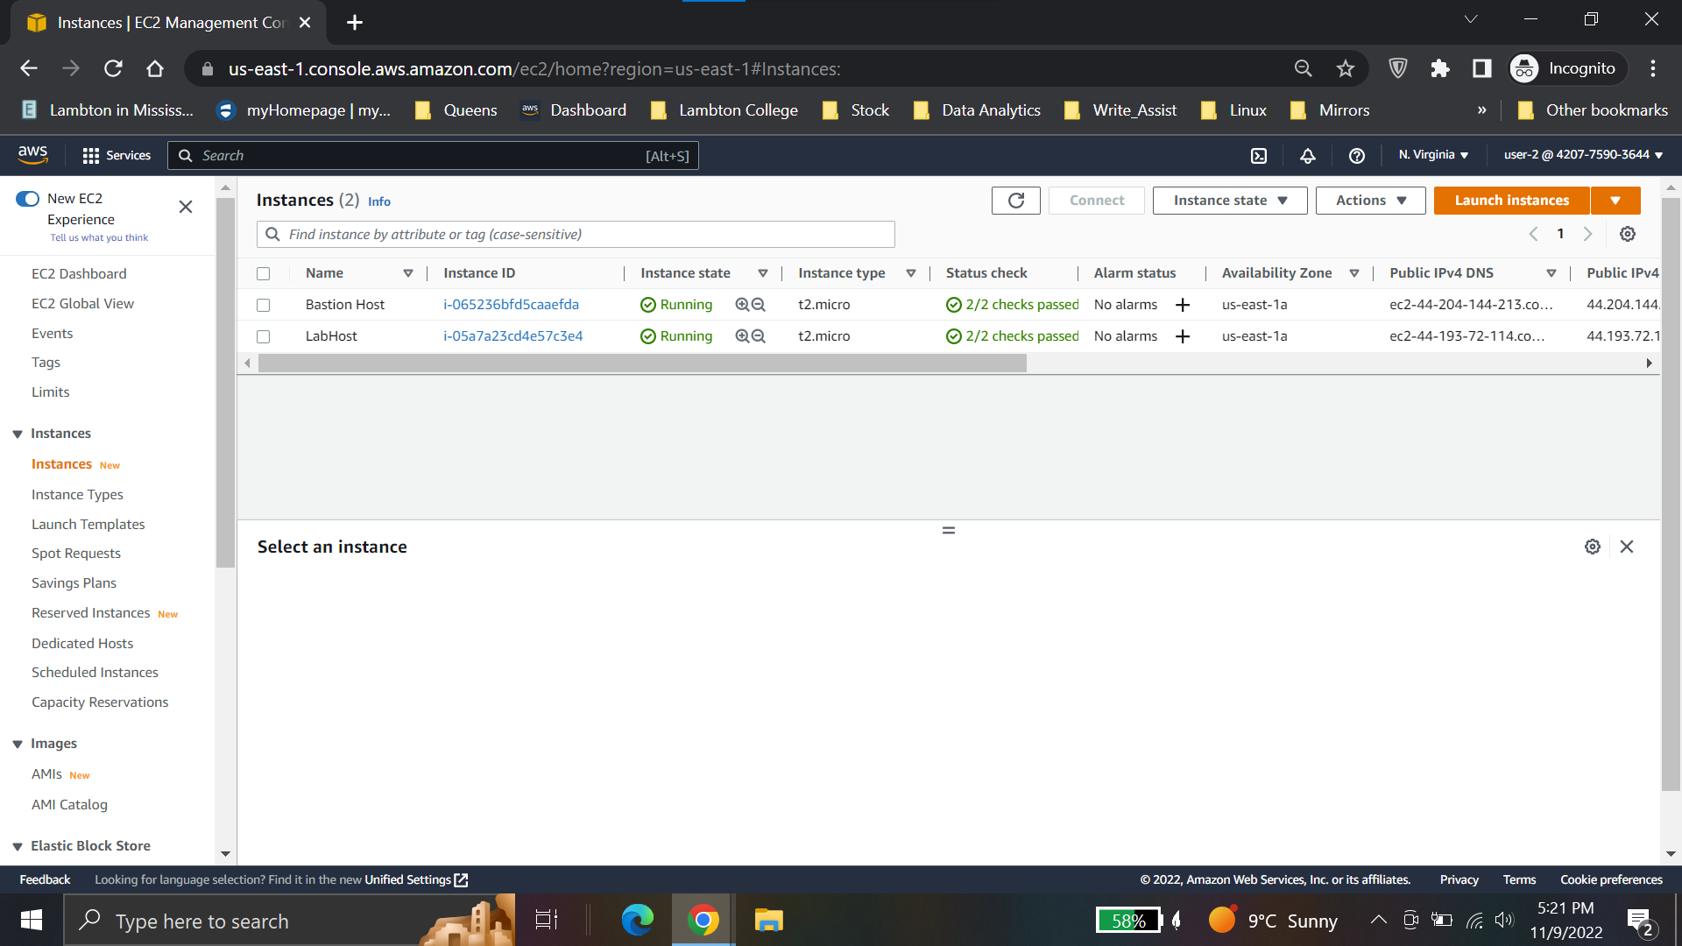

**User-2 can stop Ec2 instances**

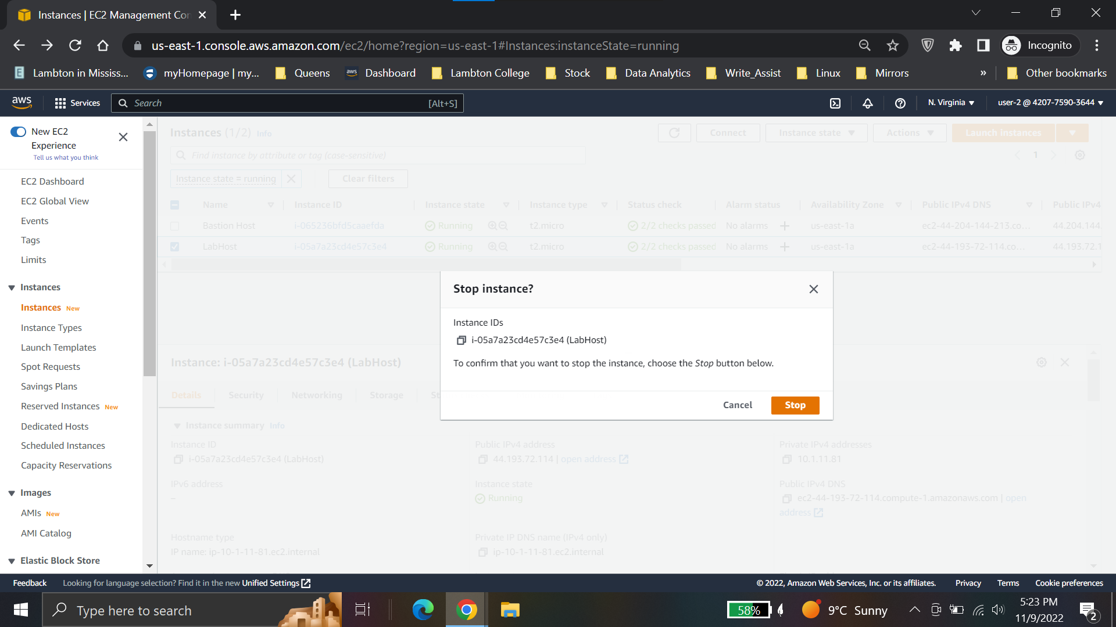

**User-2 does not have access to S3**

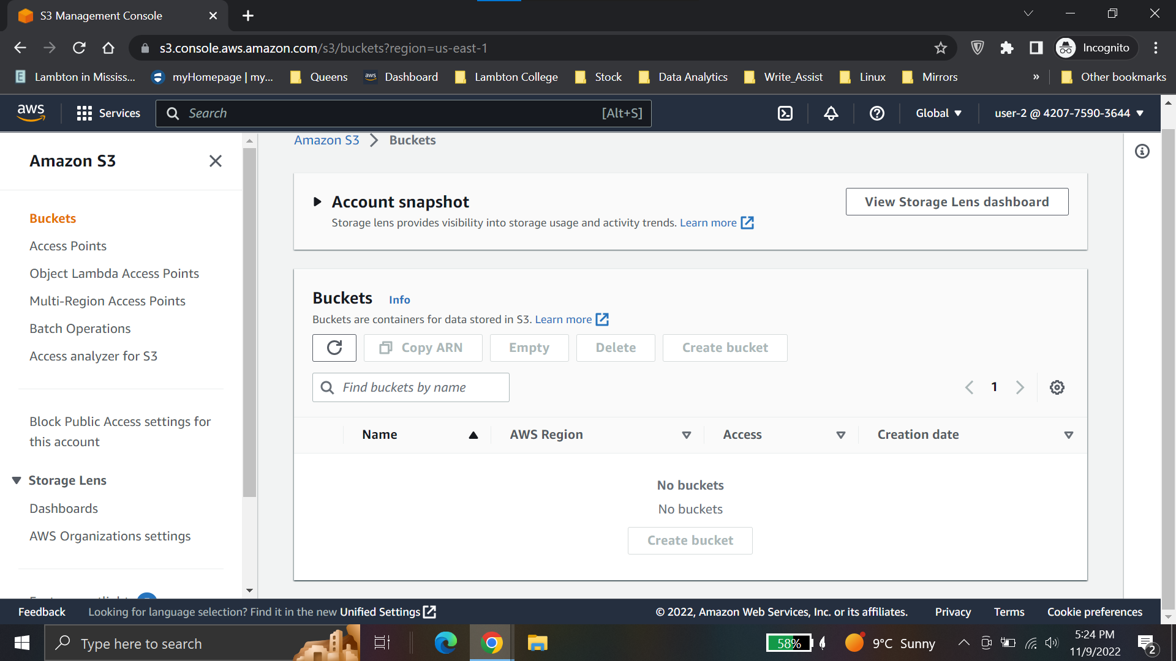

**User -3 is able to stop EC2 instance**

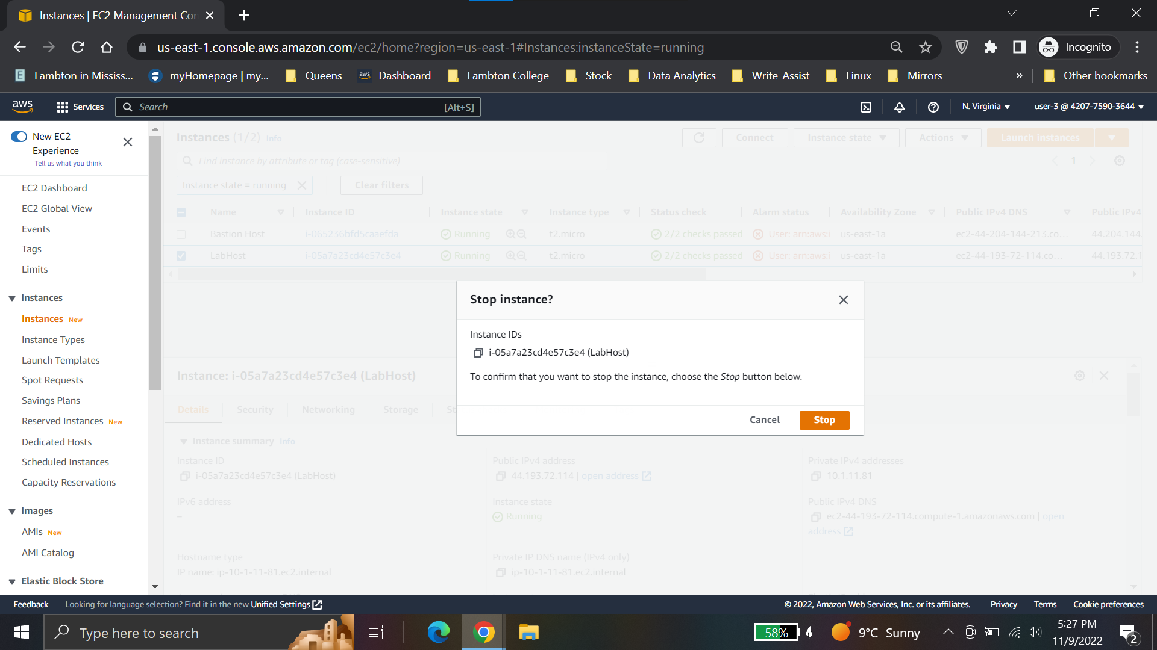

**Conslusions for Lab1**

* Explored pre-created IAM users and groups
* Inspected IAM policies as applied to the pre-created groups
* Followed a real-world scenario, adding users to groups with specific capabilities enabled
* Located and used the IAM sign-in URL
* Experimented with the effects of policies on service access

**Lab 2: Build your VPC and Launch a Web Server**

**Create VPC**

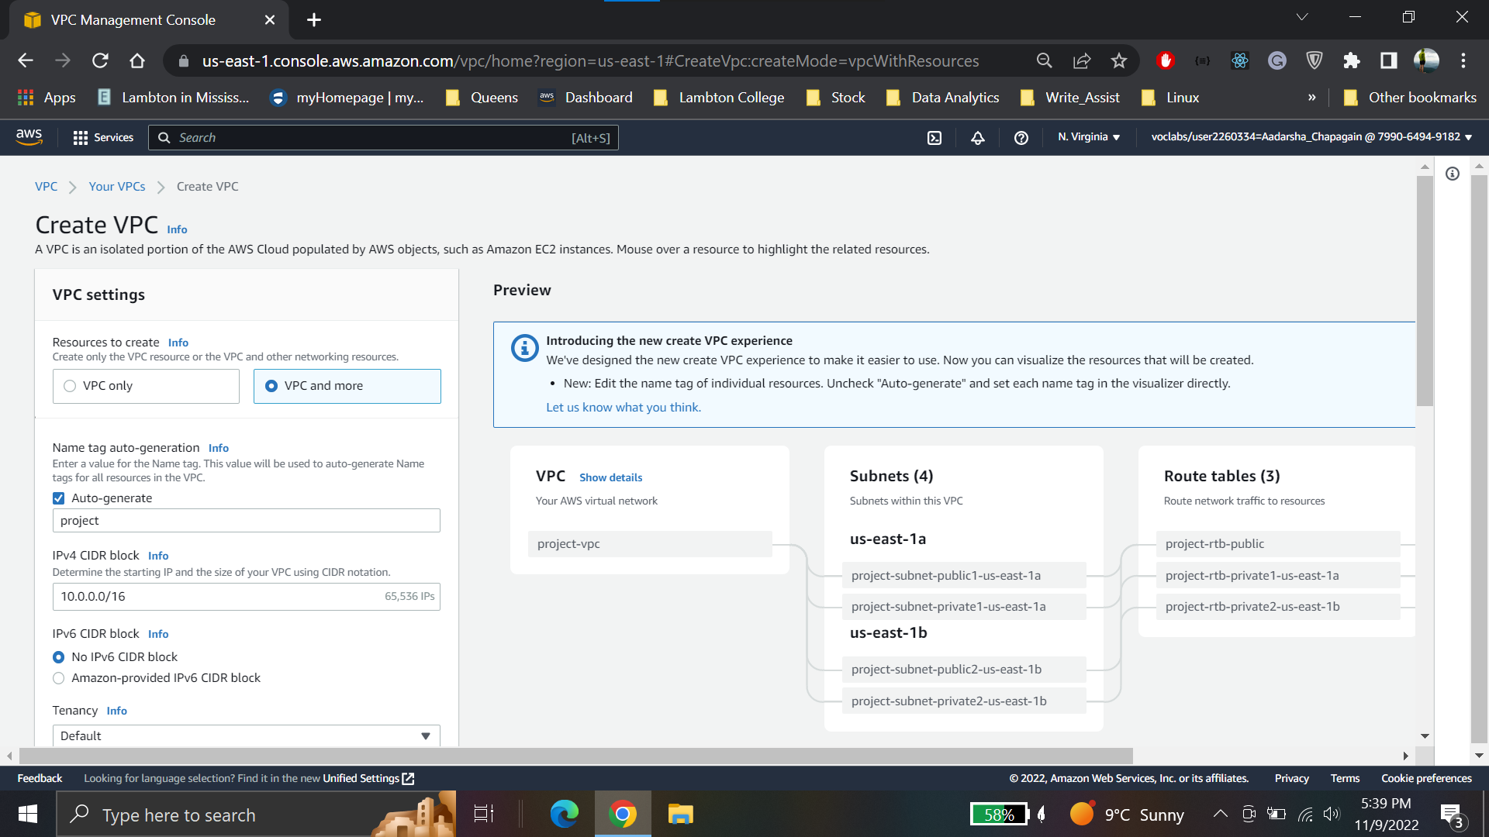

**Configuration for VPC**

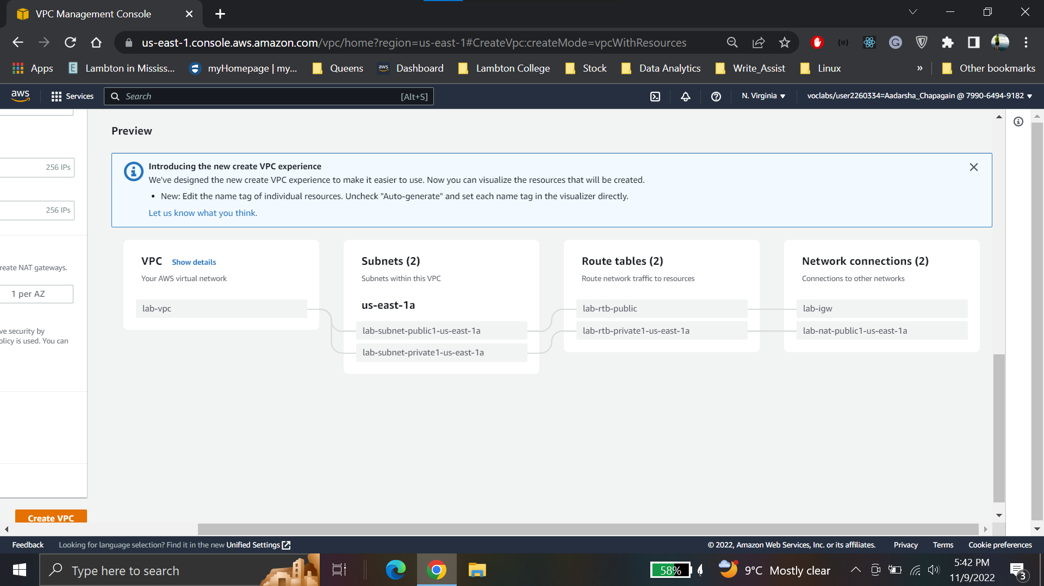

**Create Second public subnet**

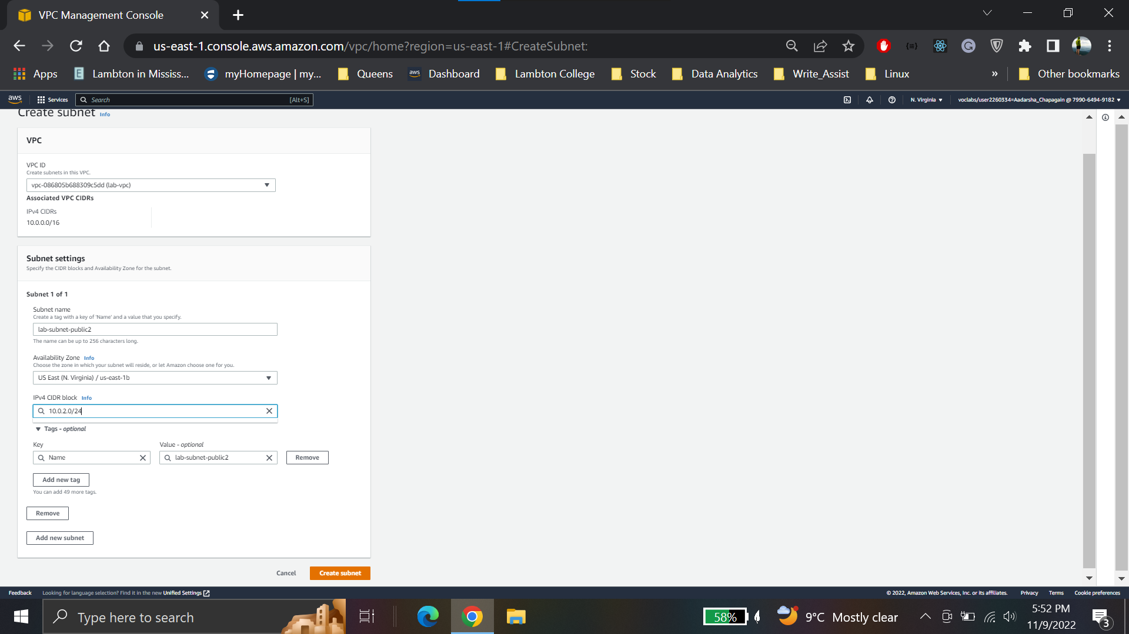

**Create Second private subnet**

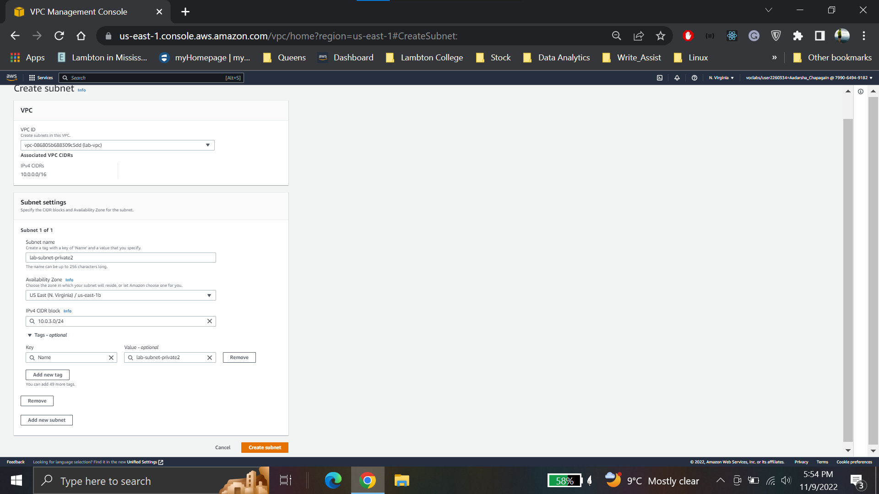

**Create Security groups**

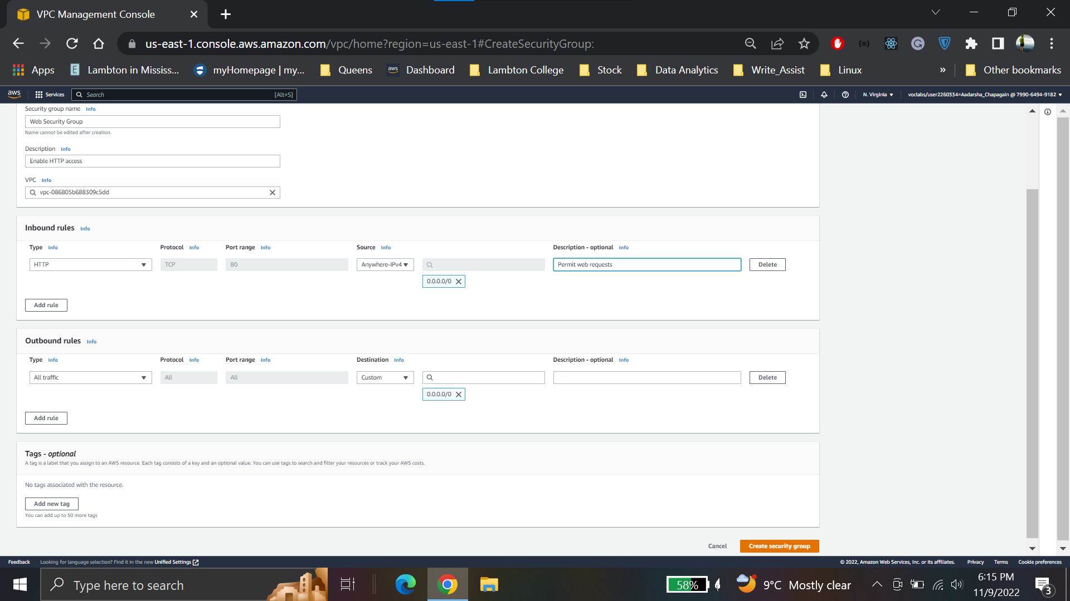

**Launch a webserver**

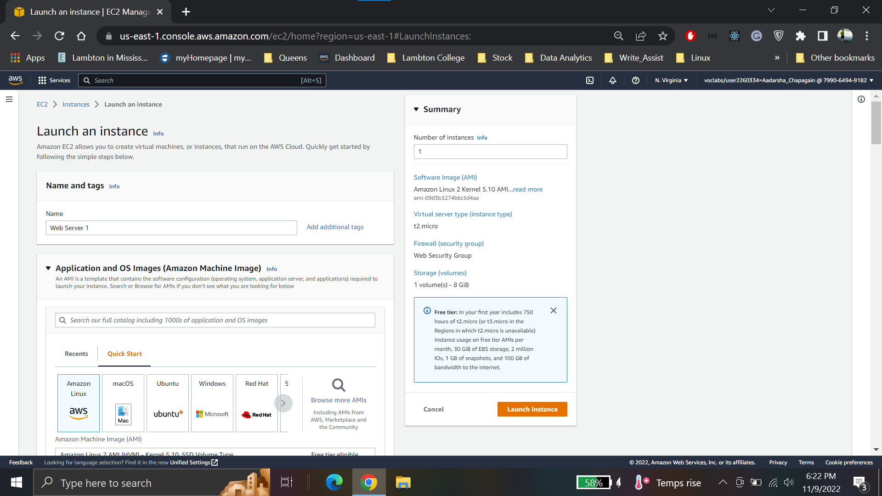

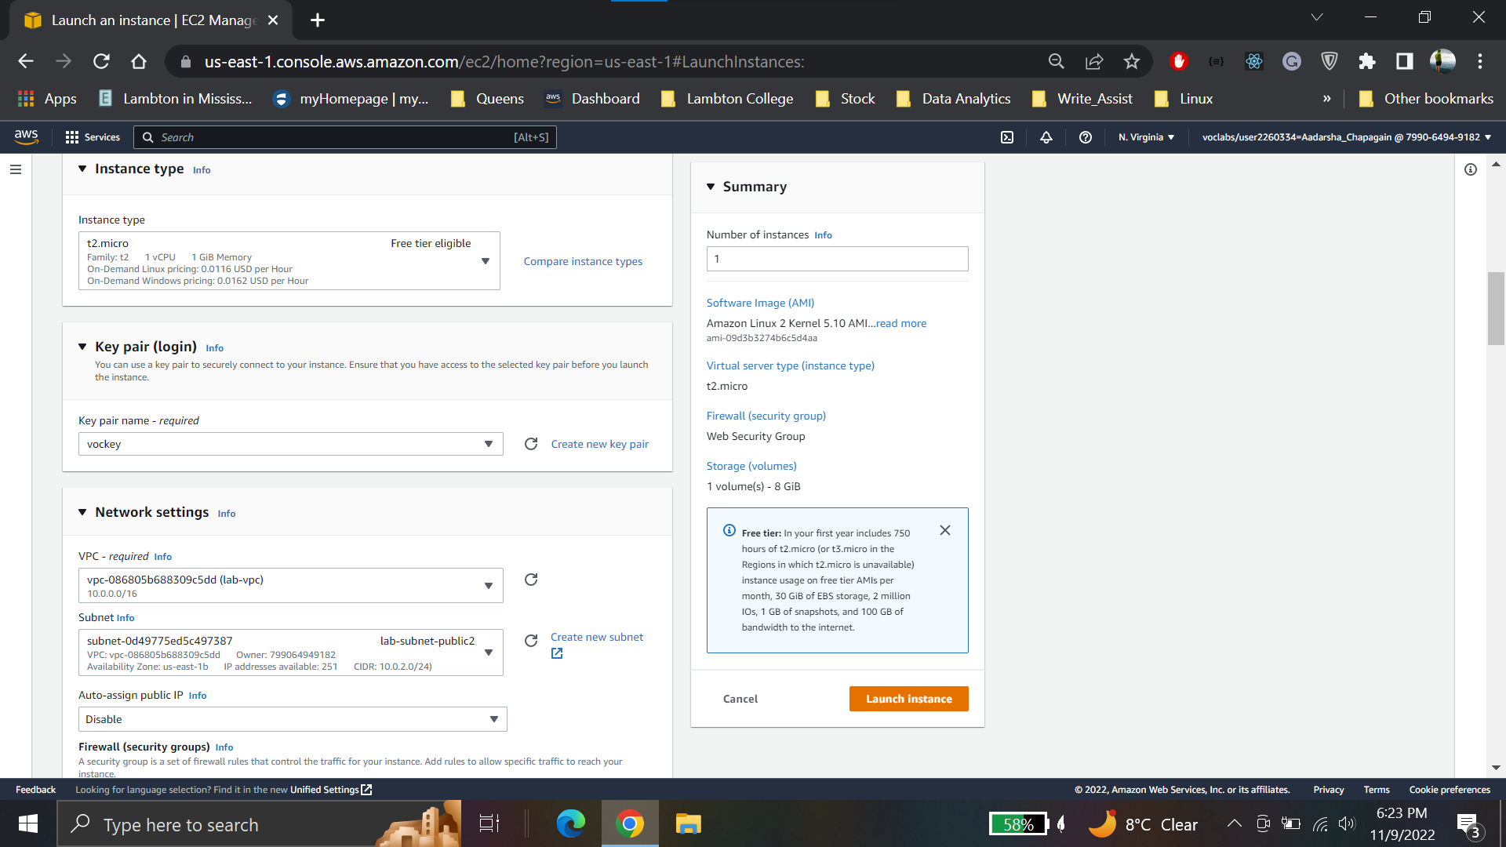

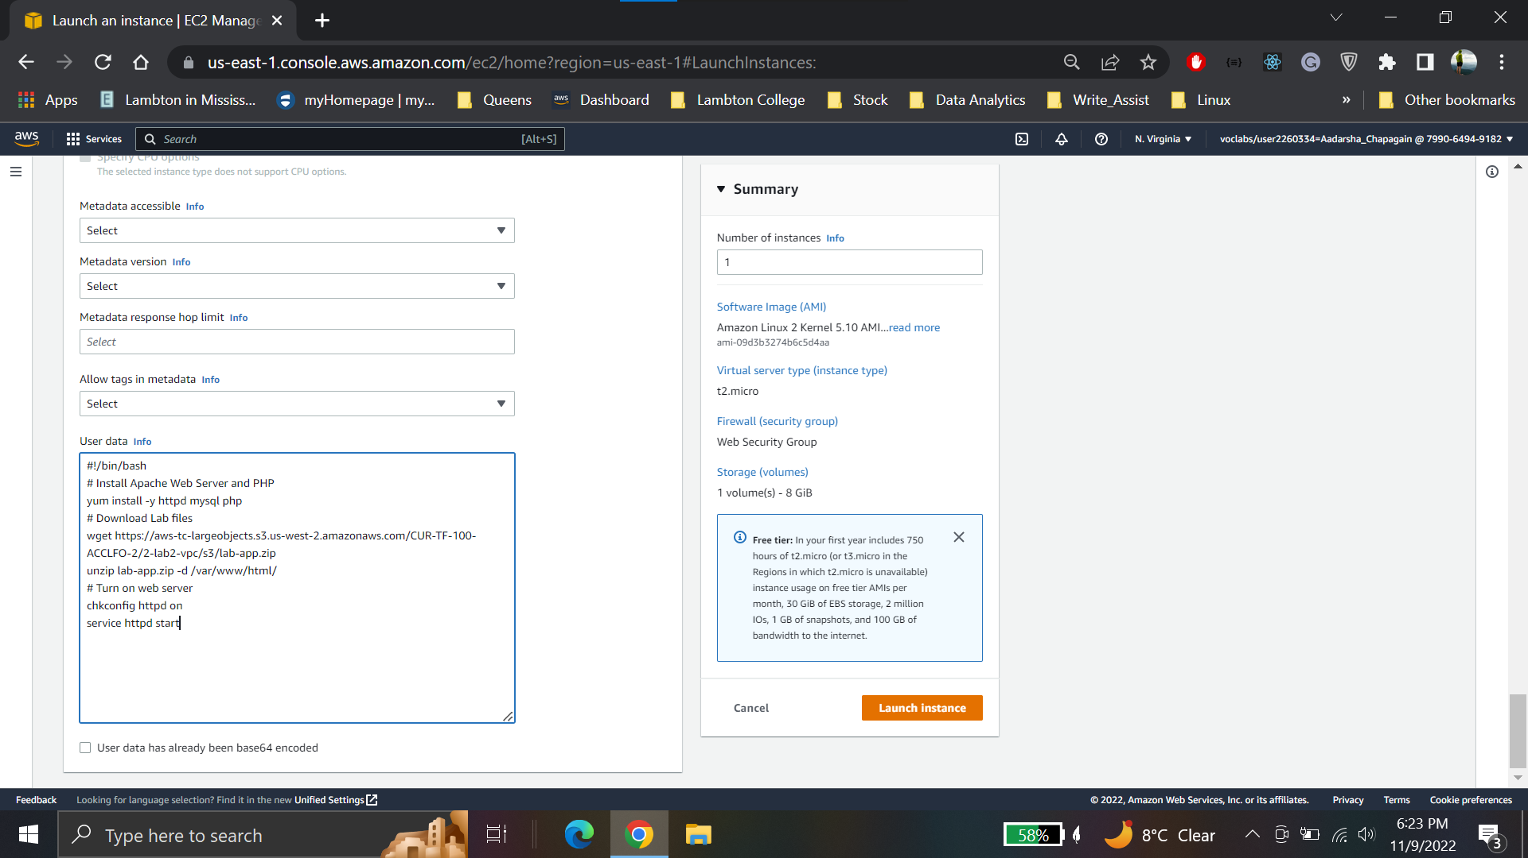

**Webserver 1 instance created**

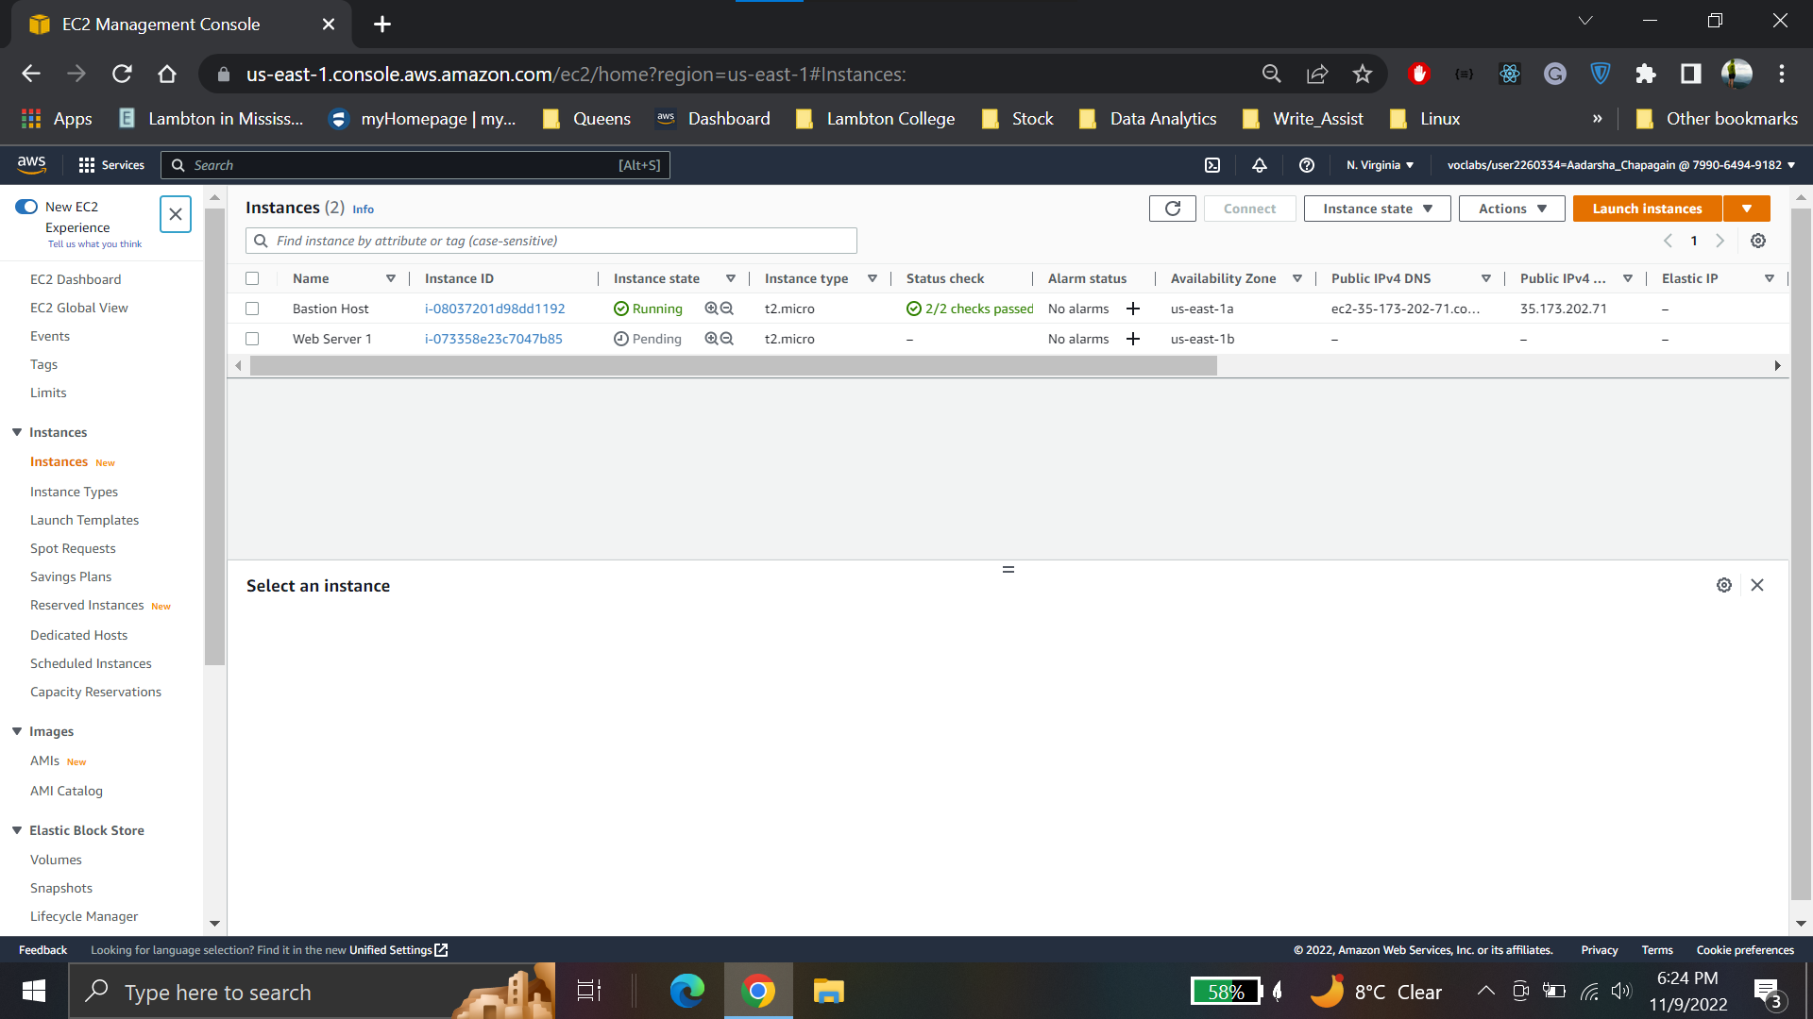

**Public DNS of instance**

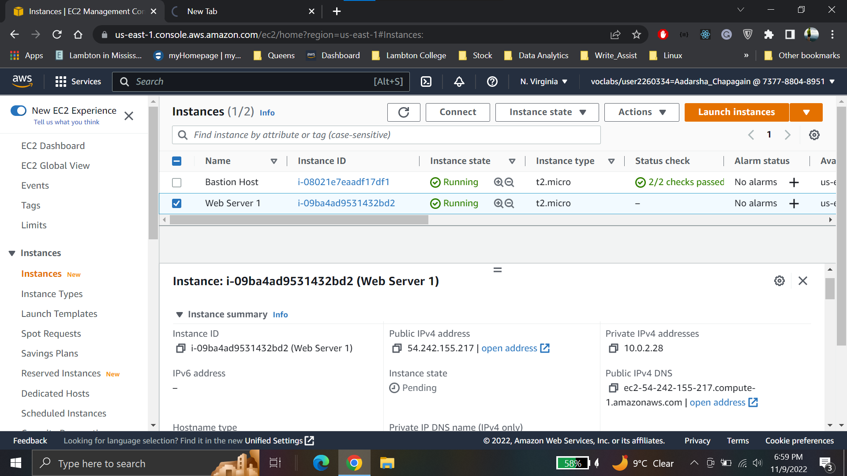

**Webserver launched successfully**

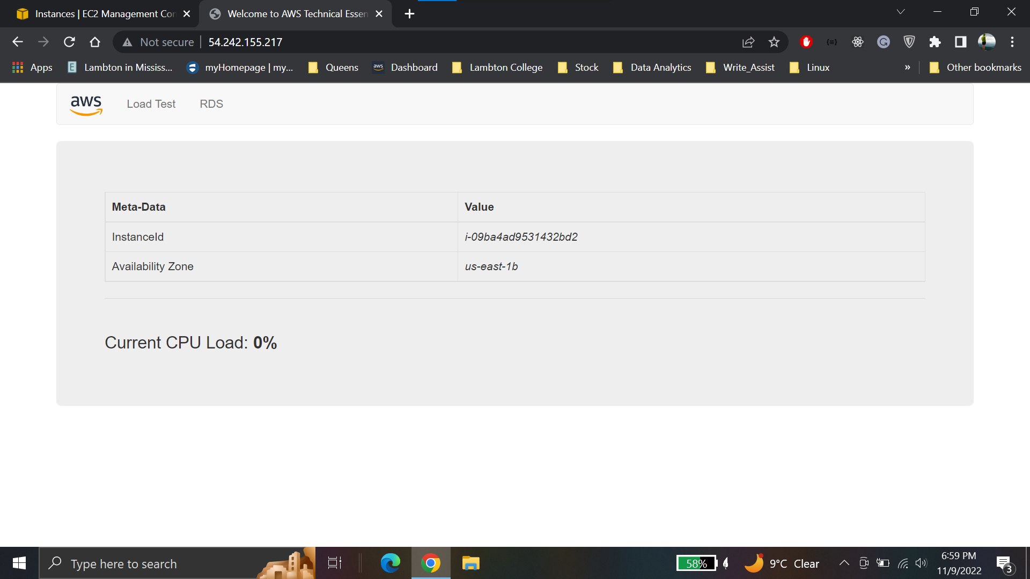

**Conclusion for Lab 2:**

* A VPC was created.
* Multiple private and public subnets were created.
* A security group was created.
* A Ec2 instance was launched on create VPC and webserver was launched.

**Lab 3 Introduction to Amazon EC2**

**Launch Ec2 instance with webserver**

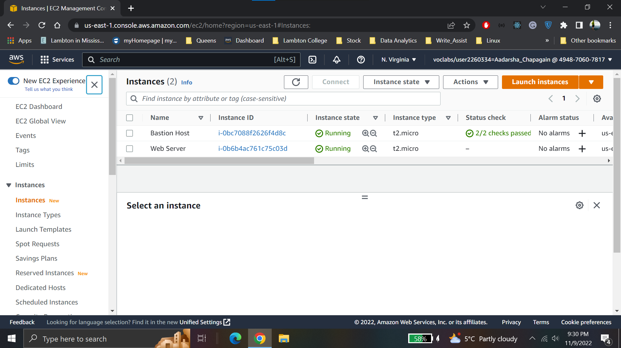

**Get instance screenshot**

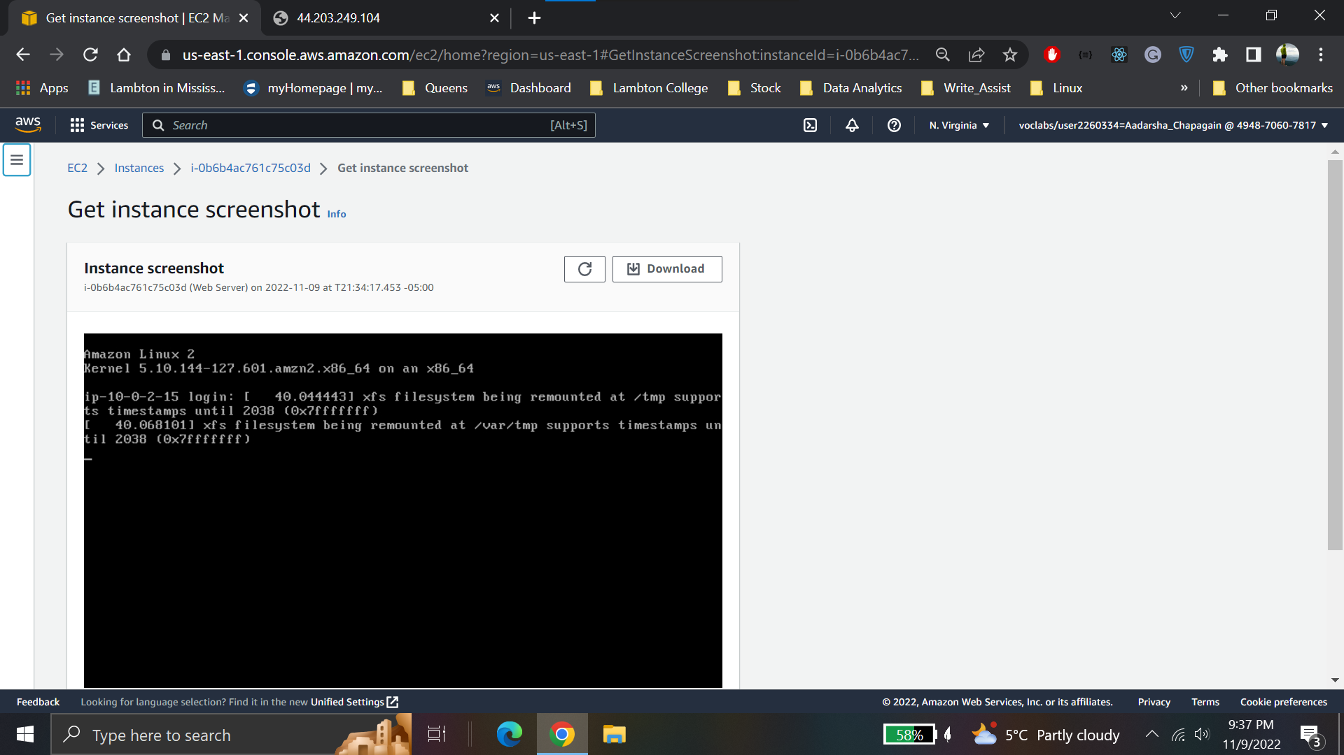

**Permit HTTP traffic into EC2 instance**

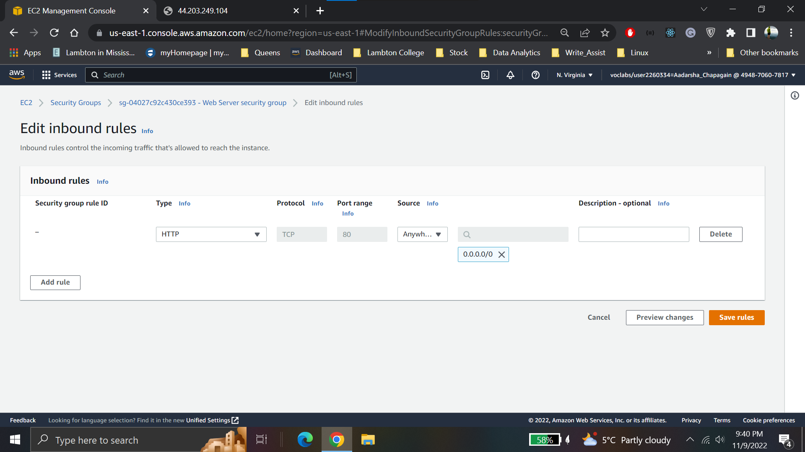

**Modify instance type from t2.micro to t2.samll and storage from 8 to 10**

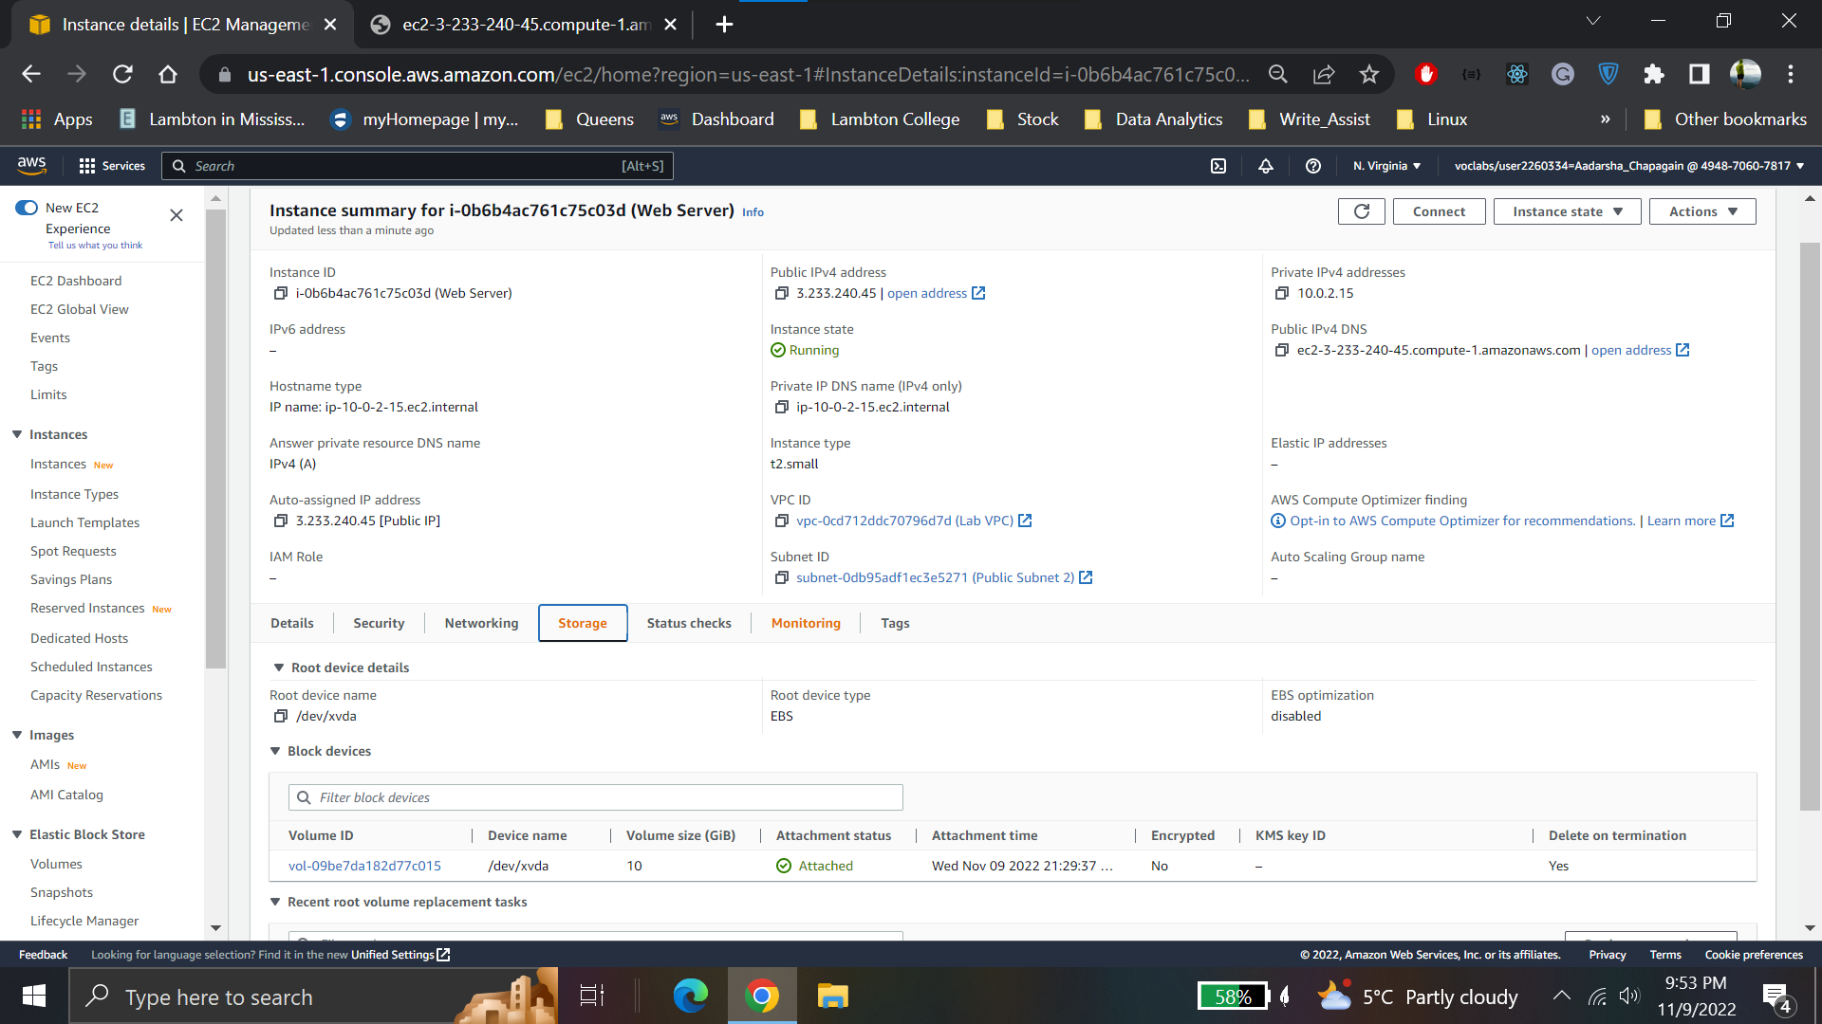

**Terminate instance**

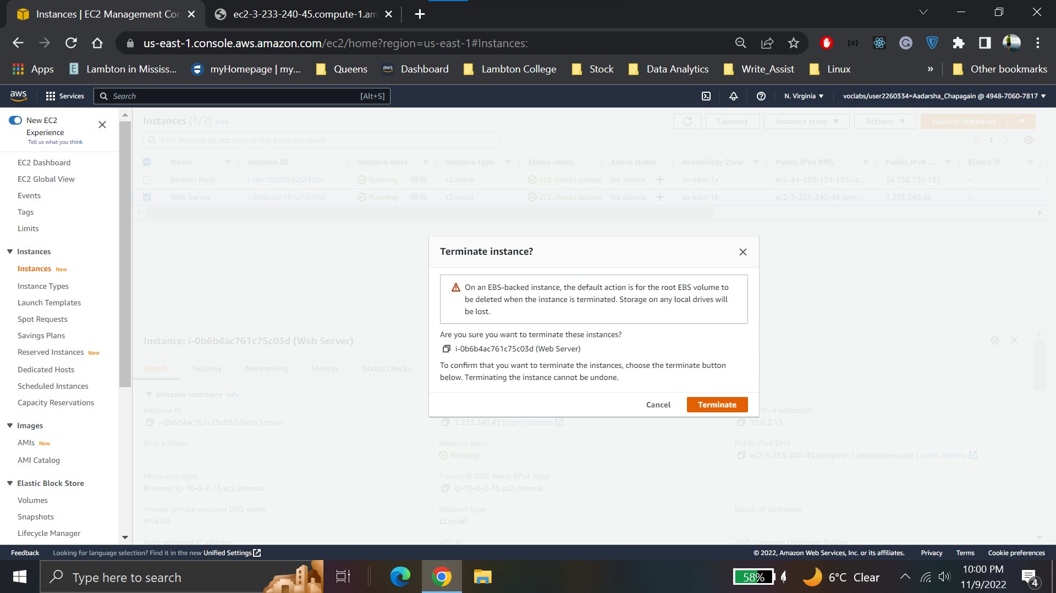

**Lab 3 conclusion**

* Launched a web server with termination protection enabled
* Monitored Your EC2 instance
* Modified the security group that your web server is using to allow HTTP access
* Resized your Amazon EC2 instance to scale
* Explored EC2 limits
* Tested termination protection
* Terminated your EC2 instance